|  |  |  |  |
| --- | --- | --- | --- |
| **CS102** | **Spring 2015/2016** | Project Group | 5H |
| Instructor: | **Özcan Öztürk** |
| Assistant: | Dorukhan Arslan |

|  |  |  |
| --- | --- | --- |
| **Criteria** | **TA/Grader** | **Instructor** |
| Presentation |  |  |
|  |  |  |
|  |  |  |
|  |  |  |
| Overall |  |  |

~ 2D Rocket Game ~

Rocket Fool

**Ömer Ekmekcioğlu, Alperen Erkek, Levent Berk Güngen,**

**Hakan Yaman Sözer, Hakan Türkmenoğlu**

|  |
| --- |
| Detailed Design Report  ( First Draft ) |

# Introduction

The game, currently titled “Rocket Fool” as with the group name, is a computer game that is created with the aim of making various principles of space travel, such as orbital mechanics, easy to understand for a general audience in an entertaining way. The game is primarily about piloting a rocket from one location to another in a two-dimensional space environment with realistic gravitation but reduced distances while managing additional concerns like fuel consumption and avoiding obstacles.

This report explains the project group’s proposal for the design of the game, disclosing details like the design patterns to be used and the existing software to integrate. It also provides a UML diagram of the core classes of the game. Finally, the report outlines the distribution of tasks to the group members.

# System Overview

## Application Format

* *Rocket Fool* will use the Model-View-Controller (MVC) pattern in its design (See Figure 1). This pattern is preferable for its flexibility and better organization in comparison with other patterns. It allows various viewing schemes to apply to the same model. This makes it easier to try different GUI ideas and would help particularly if the game is made modifiable in the future. It also makes it easier during debugging, because it is easier to tell if a problem is due to the graphics or the model itself. The separation of the controller-related code makes it much easier to test different control ideas and makes the game much easier to port to Android, if we decide to do that in the future. As with views, separating controllers also helps during debugging.
* A singleton is used to store/retrieve persistent data, such as save data and preferences.
* The game is to be a desktop application packed into a single *.jar* file. This application format is good for the game because the game is thus stand-alone and can easily be played or distributed offline after it is downloaded once from a hosting website. The format also allows the game to be more immersive as it has its own window, which can also be made full screen. Also, it doesn’t have the setbacks/limitations (like with memory shortage) that might occur in applets.

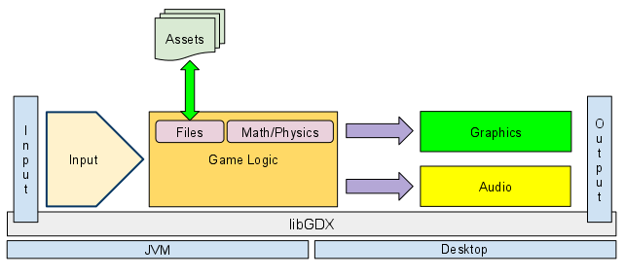

(View)

P

l

a

y

e

r

Assets

& Saves

(Model)

(Controls)

Figure 1: System Architecture Diagram

(Modified version of a typical libGDX programs’ diagram,

Source  <https://libgdx.googlecode.com/svn/wiki/img/modules_overview_diagram.png> )

## Technologies used

* While *Rocket Fool* is written in Java, it primarily employs the Java development framework libGDX because of its handy features like its extensive API, and efficient garbage collection. It is a popular framework that is used and improved by many developers.
* The Box2D physics engine, compatible with libGDX thanks to the latter’s Java native interface wrapper, serves as an efficient physics engine to create the core of the game.
* The game uses serialization for saving scores and game progress.

# Core Design Details

The following notes supplement Figure 2 (on the next page).

* The Level class does most of the work in the program including updating forces acting on the playable spacecraft.
* All game levels are extended from the Level class. Planets, assets, etc, are added to them.
* The map class determines the edges of the visible and playable map.
* SolidObject uses Box2D’s class, Body, for properties and methods of the physics engine.
* Playable objects include satellites or spaceships, depending on the level. They will be connected to controllers.
* The PositionTrigger class is used for mission objectives. It listens for a SolidObject (that will most often be a Playable) to get within a certain radius of a point (like a Waypoint location) and then triggers an event depending on the mission scenario.
* The OutOfMapTrigger and FuelDepletionTrigger are for ending the game when their respective scenarios occur, and the PositionTrigger can be used to end the game when the rocket gets close enough to a SolidObject to crash.
* Due to the requirements of the Box2D engine, floats were used instead of doubles.
* Getter and setter methods were omitted in the UML diagram to prevent crowding, but are assumed to exist where appropriate.

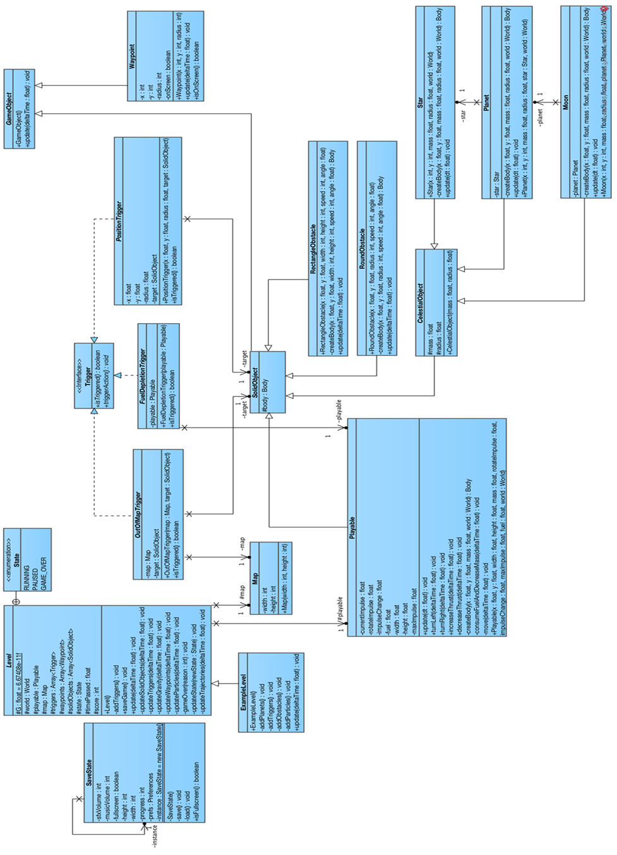

Figure 2: UML classes of model part of the game (figure also available at https://turkmenog.lu/static/cd8.png)

# Task Assignment

## Ömer

* In-Game screen GUI (some parts)
* Scenario and script preparation

## Alperen

* Menu screens’ classes and GUI
* Animations and graphics
* Cutscenes
* Sounds

## Levent

* SaveState class
* Level class (some of the methods)
* Learning content preparation

## Yaman

* In-Game screen GUI (some parts)
* Map class
* Obstacle classes
* Waypoint class
* Trigger classes

## Hakan

* Playable class
* GameObject and SolidObject classes
* Celestial Body class and subclasses
* Level class (most of it)
* Control classes
* Camera/viewpoint classes

## All group members

* Level design and coding
* Debugging
* Balancing
* Playtesting and reflecting
* Collecting assets, such as illustrations for dialog boxes or music.